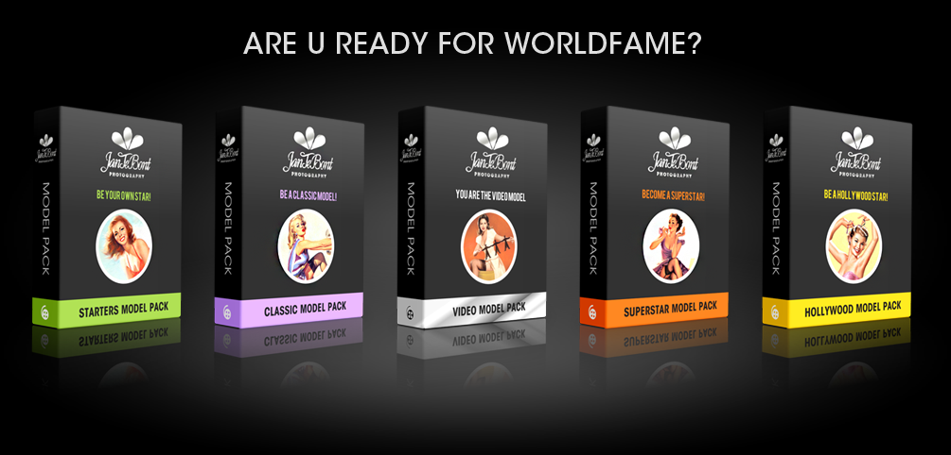

JAN TE BONT MODEL PACKS

CLASSIC MODEL PACK: 349 EURO
CLASSIC+ MODEL PACK: 429 EURO
VIDEO MODEL PACK: 589 EURO
SUPERSTAR MODEL PACK: 900 EURO
HOLLYWOOD MODEL PACK: 2800 EURO

EXTRA OPTIONS
- 1 EXTRA RETOUCHED PHOTO 25 EURO
- 5 EXTRA RETOUCHED PHOTOS 99 EURO
- INSTAGRAM MOVIE PROMO 15 SEC 149 EURO
- VIDEOCLIP(S) ON BLUE-RAY FULL HD 149 EURO
- FIRST 5 FOTO’S IN 24 HOURS 149 EURO
- CUSTOM-MADE LOGO BY DIGITAL TRAFFIC 249 EURO
- DUO SHOOT 2ND PERSON CALL

